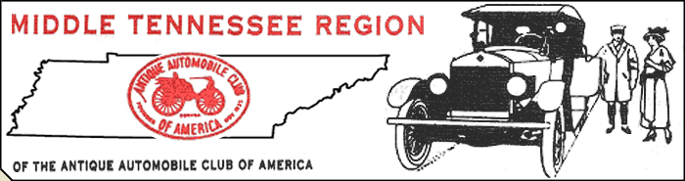
Glenn Edwards, President ~ Dr. Roger McKinney, Vice-President ~ Read Majors, Secretary ~ Marc Humes, Treasurer

March 2010

Here's hopin' the weather breaks soon. I don't know about you, but I'm SICK of winter! We have a bunch of events coming up this year and I can't wait to get started! Our kick-off is “Dumplin' Days” on April 17th. DD's is held at our fairgrounds and will feature something for everyone. It will not be an actual car show, but some member's cars will be on display. More details coming up later. This should be fun so let's have a big turnout for this season opener.
Since our last newsletter we have bid farewell to our friend David Weigant. David fought a valiant battle with cancer and left us all a little richer for having known him. We want to welcome David's son Tony and his wife Christy as new members. Betty, Tony and Christy will make sure the Weigant spirit continues in our club.
A big MTR welcome also to new members Don and Joyce Fox and Bill and Barbie Walski. Glad to have you on board and part of our “car family.” Everybody be on the lookout for potential new members to keep our club strong and growing.
- Our next meeting will be on March 14th at 2PM in the grove clubhouse. All members need to attend because each voice is important and there's always plenty of business to discuss.
- Potluck Supper – March 26th at 6:30PM. Bring a side dish / dessert, club will provide main course.
- I have sent the 2010 roster to National HQ as required, so if you haven't paid dues (local or Nat'l) you need to do it right away in order to keep your AACA status active. Call me if you have questions (Read Majors – 483-2661).

MTRAACA EVENTS 2010
April 17th – Dumplin' Days at the Fairgrounds (bring your cars for display during Fiddler's Grove's newest event)
May 2nd – Mt. Juliet Car Show at WB&T
May 29th – Granville Heritage Days
June 27th – Murfreesboro Summerfest at WB&T ( Hwy 231 Murf.)
August 15th – Wilson County Fair
Sept. 10 and 11th – Red Boiling Springs
Sept. 18th – Gladefest
October 17th – Oktoberfest at WB&T (main office)

